Dr. D. Y. Patil Pratishthan’s

**D. Y. Patil Institute of MCA and Management**

Sector No.29, Behind Akurdi Railway Station, Pradhikaran, Nigdi, Pune – 411044

Tel No: 020-27640998, 202737393, Fax no: 27653054,Website: www.dypimca.ac.in, Email: director@dypimca.ac.in

**(Approved by AICTE, Recognized by DTE, Mah.; Affiliated to SPPU)**

**CERTIFICATE**

This is to certify that the project entitled

**“Pune Housing-Find your own home”**

**FOR**

**AIT Mini Project**

Has been successfully partially completed

By

**Mr. Hitesh Zhambare**

Towards the partial Fulfilment of

M.C.A (Master of Computer Applications)

Under

Savitribai Phule PuneUniversity for

Academic year 2019-2020

**Ms. Sheetal Patil . Mrs. Manasi Pandharkar Mrs. Priti Naidu**

**Project Guide**

**Dr. Kavita Suryawanshi Dr. K. Nirmala**

**HOD, MCA Director**

Dr. D. Y. Patil Pratishthan’s

**D. Y. Patil Institute of MCA and Management**

Sector No.29, Behind Akurdi Railway Station, Pradhikaran, Nigdi, Pune – 411044

Tel No: 020-27640998, 202737393, Fax no: 27653054,Website: www.dypimca.ac.in, Email: director@dypimca.ac.in

**(Approved by AICTE, Recognized by DTE, Mah.; Affiliated to SPPU)**

**CERTIFICATE**

This is to certify that the project entitled

**“Pune Housing-Find your own home”**

**FOR**

**AIT Mini Project**

Has been successfully partially completed

By

**Mr. Parag Trivedi**

Towards the partial Fulfilment of

M.C.A (Master of Computer Applications)

Under

Savitribai Phule PuneUniversity for

Academic year 2019-2020

**Ms. Sheetal Patil . Mrs. Manasi Pandharkar Mrs. Priti Naidu**

**Project Guide**

**Dr. Kavita Suryawanshi Dr. K. Nirmala**

**HOD, MCA Director**

**INDEX**

|  |  |  |
| --- | --- | --- |
| **Sr. No** | **Particulars** | **Page No.** |
| 1 | **Chapter 1: Introduction** |  |
| 1.1) Existing System and Need for System |  |
| 1.2)Scope of work |  |
| 1.3)Technology Used / Operating Environment  (software and Hardware) |  |
| 2 | **Chapter 2**: **Proposed System** |  |
| 2.1) Proposed System |  |
| 2.2) Objectives of System |  |
| 2.3) Module Specification |  |
| 2.4) User Requirements |  |
| 3 | **Chapter** **3**: **Analysis & Design** |  |
| 3.1) Context Level & 1st Level DFD |  |
| 3.2)ERD |  |
| 3.3) Use Case |  |
| 3.4)Sequence Diagram |  |
| 3.5) Activity Diagram |  |
| 3.6) Class Diagram |  |
| 3.7) Object Diagram |  |
| 3.8) Table Design [Sr no. Name, Type, Size ,Constraint, description ] |  |
| 4 | **Chapter** **4:** **User Manual** |  |
| 4.1) User Manual |  |
| 5 | **Drawbacks or Limitation** |  |
| 6 | **Future Enhancements** |  |
| 7 | **Conclusion** |  |
| 8 | **Bibliography** |  |
| 9 | **Annexures** |  |
| Annexures  1 : Input Forms With Data  (Input screen With Validations) |  |
| Annexures  2: Output Reports With Data |  |
| Annexures  3: Sample Code |  |

**ACKNOWLEDGEMENT**

I would take the opportunity to thank **Dr. K Nirmala,** **Director, DYPIMCAM for** her support, extended to me throughout the course. I would like to thank **Dr. Kavita Suryawanshi, HOD,MCA**, for her scholarly disposition, timely guidance, support and cooperation.

I would like to thank **Ms. Sheetal Patil . Mrs. Manasi Pandharkar Mrs. Priti Naidu**, for his/**her** kind guidance, keen interest, continuous encouragement and inspiration throughout the project work.

Also wholeheartedly express thankfulness to **Ms. Sheetal Patil. Mrs. Manasi Pandharkar Mrs. Priti Naidu** for her, enthusiasm and advice.

Finally, I gratefully thank all the staff members of DYPIMCAM for their cooperation and support.

I also thankful to get constant encouragement, support and guidance from all Teaching and Non- Teaching Staff for their timely support which helped us in successfully completion of our project work.

**Roll No :-**

**Student Name :-**

**Signature :-**

**Chapter 1: Introduction :**

This website will help you to buy / rent a home.

we created a unique property search platform that filled the gaps left by others in the market.

Born out of the need to simplify the search for a home.

* 1. **Existing System and Need for System :**

Before people were Rome around near by area’s and ask for home/flat.

Now, they can visit to our website and search for home/flat by location and direct contact with owner’s.

**Need For System:**

To be the first choice for our consumers and partners in their journey of discovering, renting, buying, selling and financing a home.

* 1. **Scope of Work :**

This will help the people for searching home in pune.

People can buy/rent a property by location in pune.

If the customer wants to sell their properties ,they can update there details(pictures , locations, flat type , rooms).

**1.3 Technology Used / Operating Environment (software and Hardware) :**

**Technology :**

**Front End :**

Html 5

Boostrap

Javascript

Css

**Back End :**

php

Sql

Javascript

**Hardware:**

Processor : Intel I3 or above.

Ram : 1 GB or above.

HDD: 300 GB or above.

**Software :**

Operating system : Windows 7 or above.

Web Browser: Chrome , Mozila , Firefox ect.

Development tools: HTML, CSS, ASP.

Database: Microsoft Access.

**Chapter 2: Proposed System:**

**2.1 Proposed System:**

House Buy/rent management system in proposed system is used to search the room in particular place in flats, Apartments, room ,office, paying guest, office also. it is user friendly Website. House management system is used to search the available location and available an the space .

**2.2 Objectives of System:**

Housing sector remains vigilant to face the challenges of change by employing a new strategy that facilitates easy management of rental houses. The Rental Management System is save an the time also. The Rental Management System is used to easily identify the suitable place in Save time, cost also.

**2.3 Module Specification:**

**1. Rent :**

If you want home/flat on rent you have two options by agent or by owner.

Here you can search home/flat by specific area in pune.

There are many options available that you can choose like.

Type – family , bachelor

Furnished- semi , fully.

Property type- apartment , villa.

Area – 700 sq ft. (approx).

Age of property – 10 years.

Facilities – gym , swimming pool , garden.

**2. Buy :**

You can buy a home/flat in pune by agent or by owner.

Here there are some options available to buy a property.

Property type- apartment , villa.

Area – 700 sq ft. (approx).

Age of property – new / old.

Facilities – gym , swimming pool , garden.

**3. Sell :**

You can sell a home/flat, property in pune by agent also.

Here there are some options available to buy a property.

Property type- apartment , villa , office etc.

Area – 700 sq ft. (approx).

Age of property – new / old.

Facilities – gym , swimming pool , garden.

**2.4 User Requirements:**

User wants a reliable and user-friendly system with accurate and efficient information provided by the system. This is the main requirement of the user. As far as possible the input screens format should match with the input document. But for the adjustment of space on the screen, if the screen format is changed, at least sequence of reading the values from input form and feeding them to the screen must be maintained. The proper report format is to be prepared according to need. Security of data must beprovided using logins.

**Chapter 3**: **Analysis & Design:**

**3.1 Context Level & 1st Level DFD :**

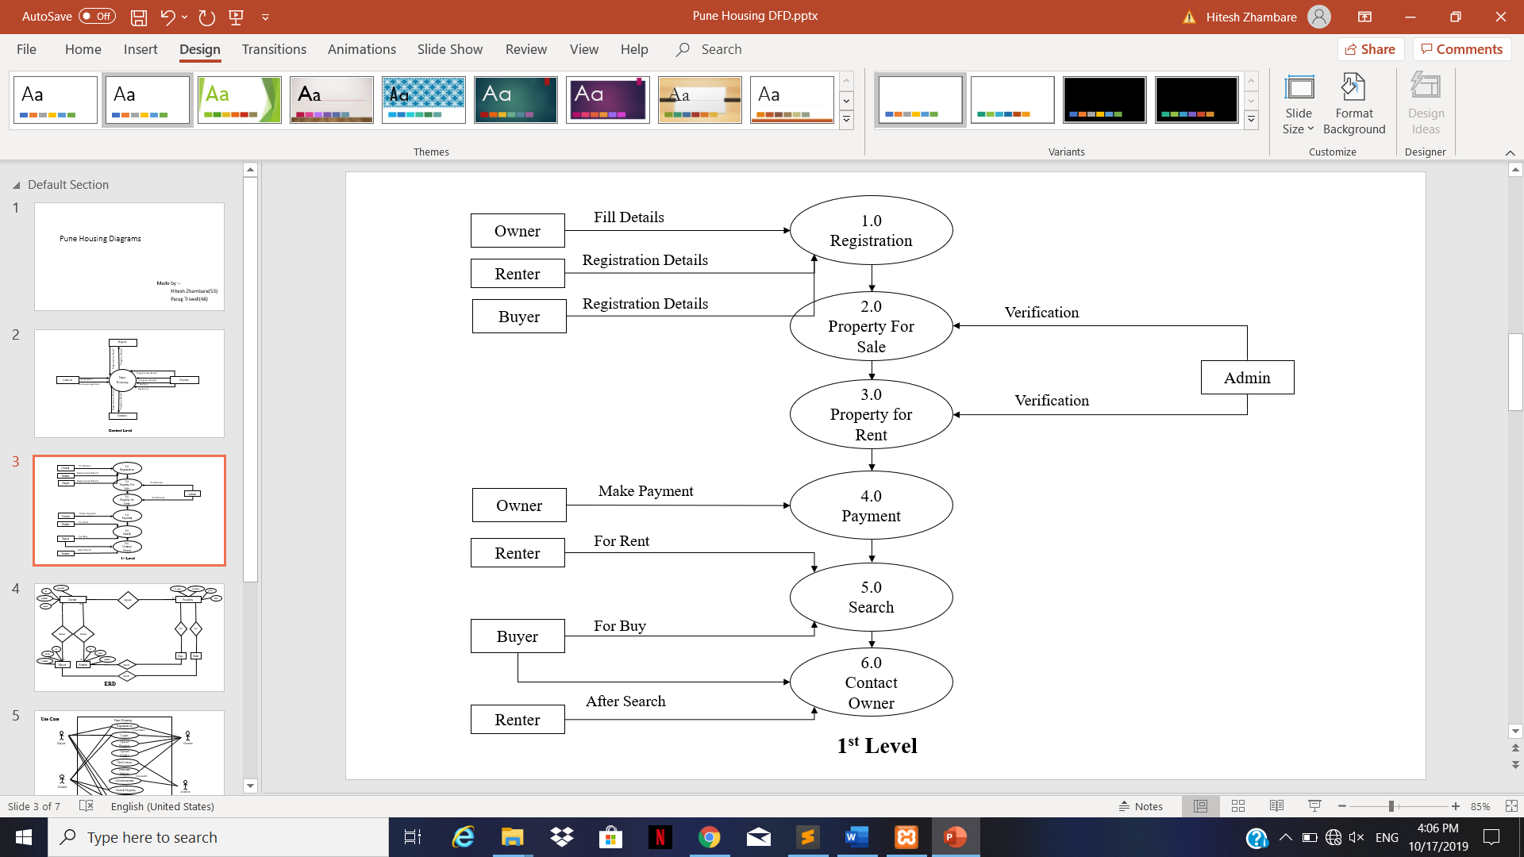

**3.2 ERD :**

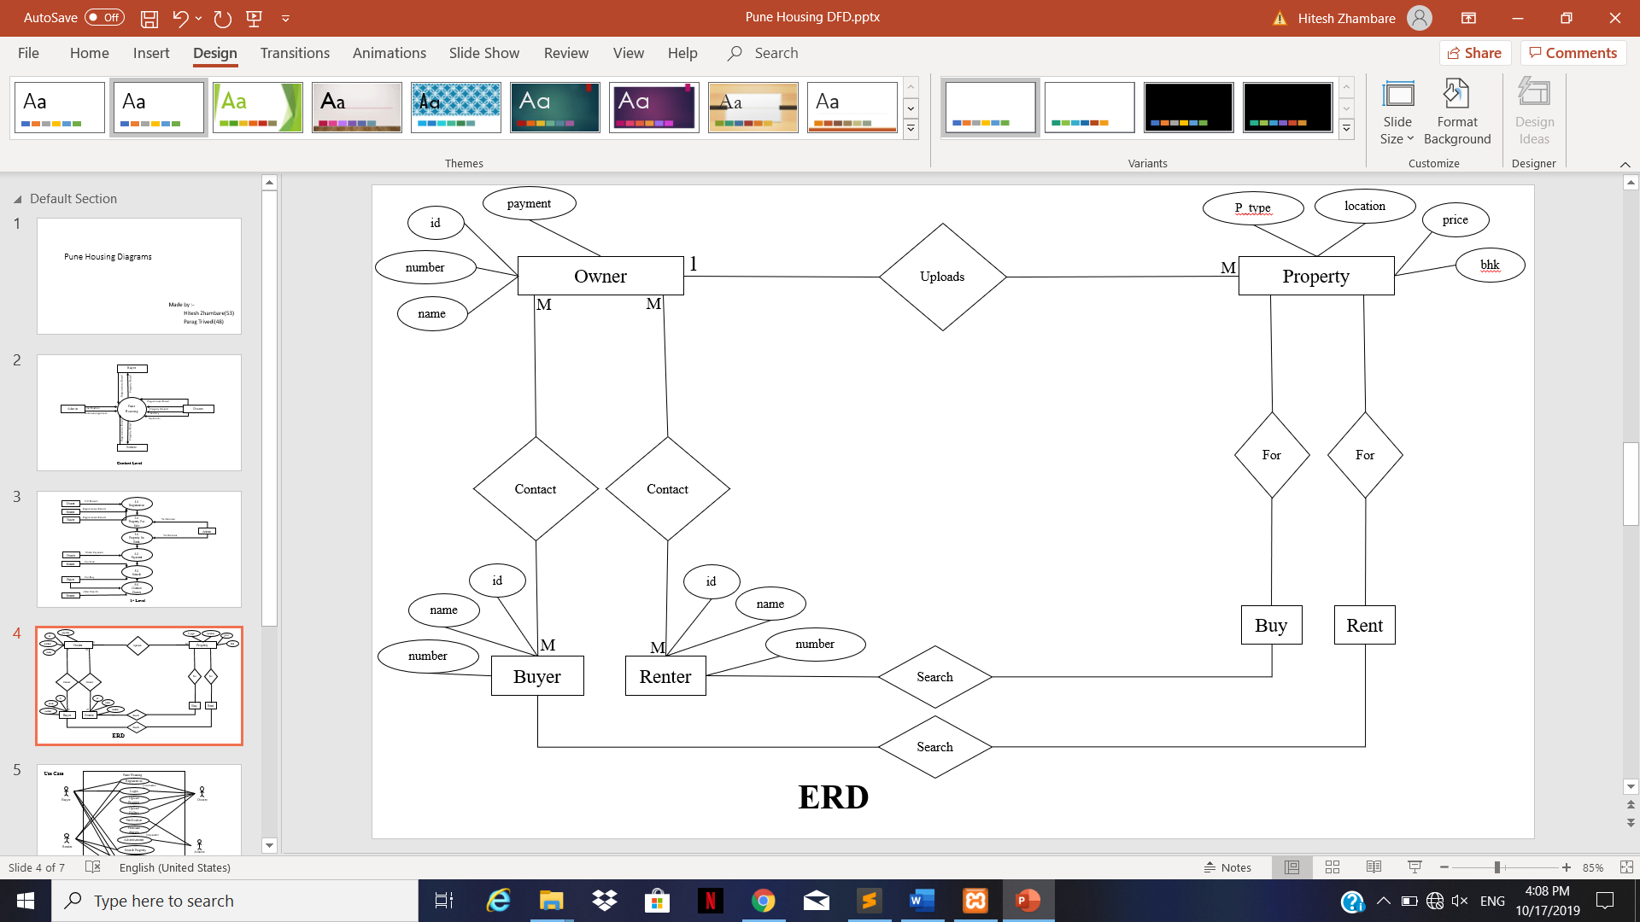

**3.3 Use Case :**

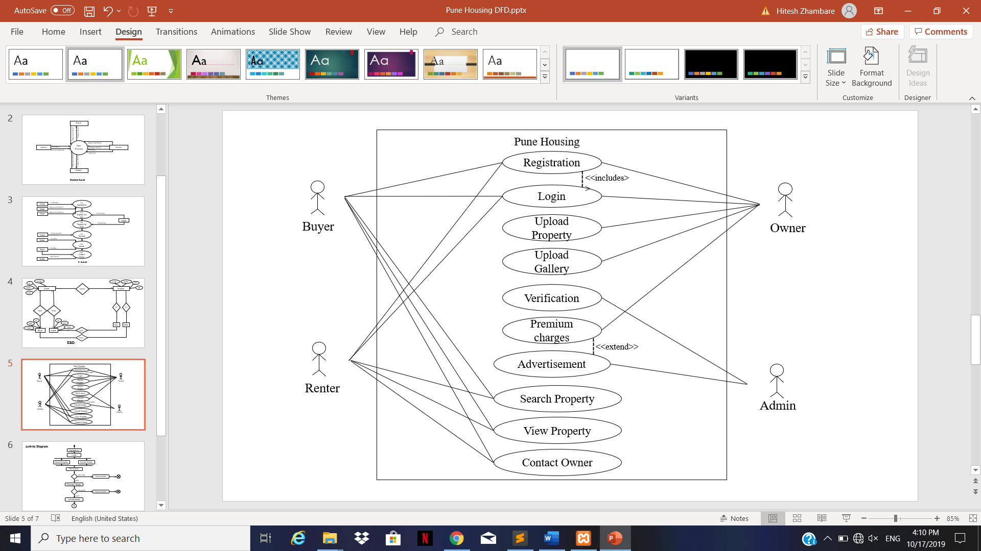

**3.4 Sequence Diagram:**

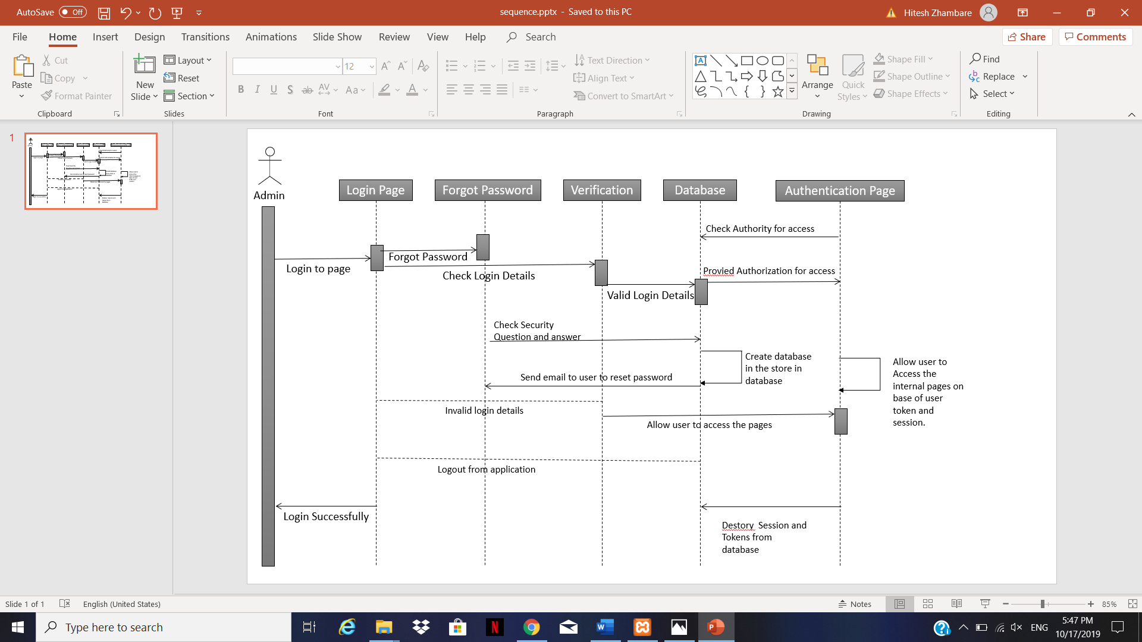

**3.5 Activity Diagram :**

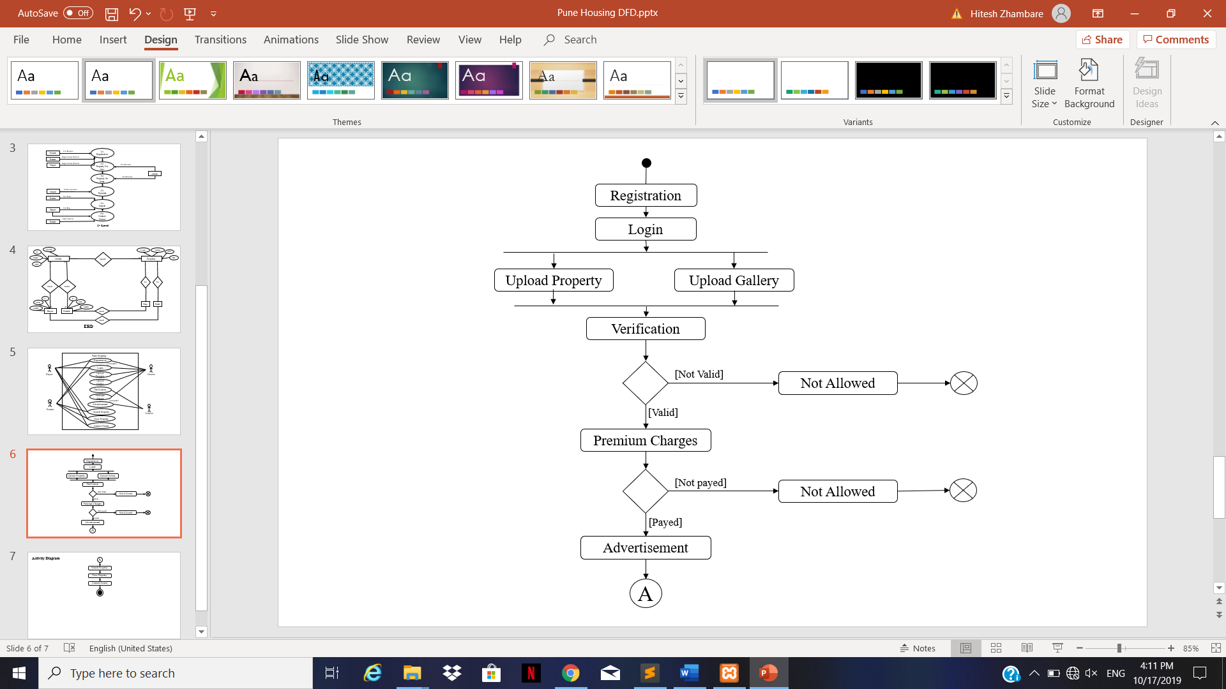

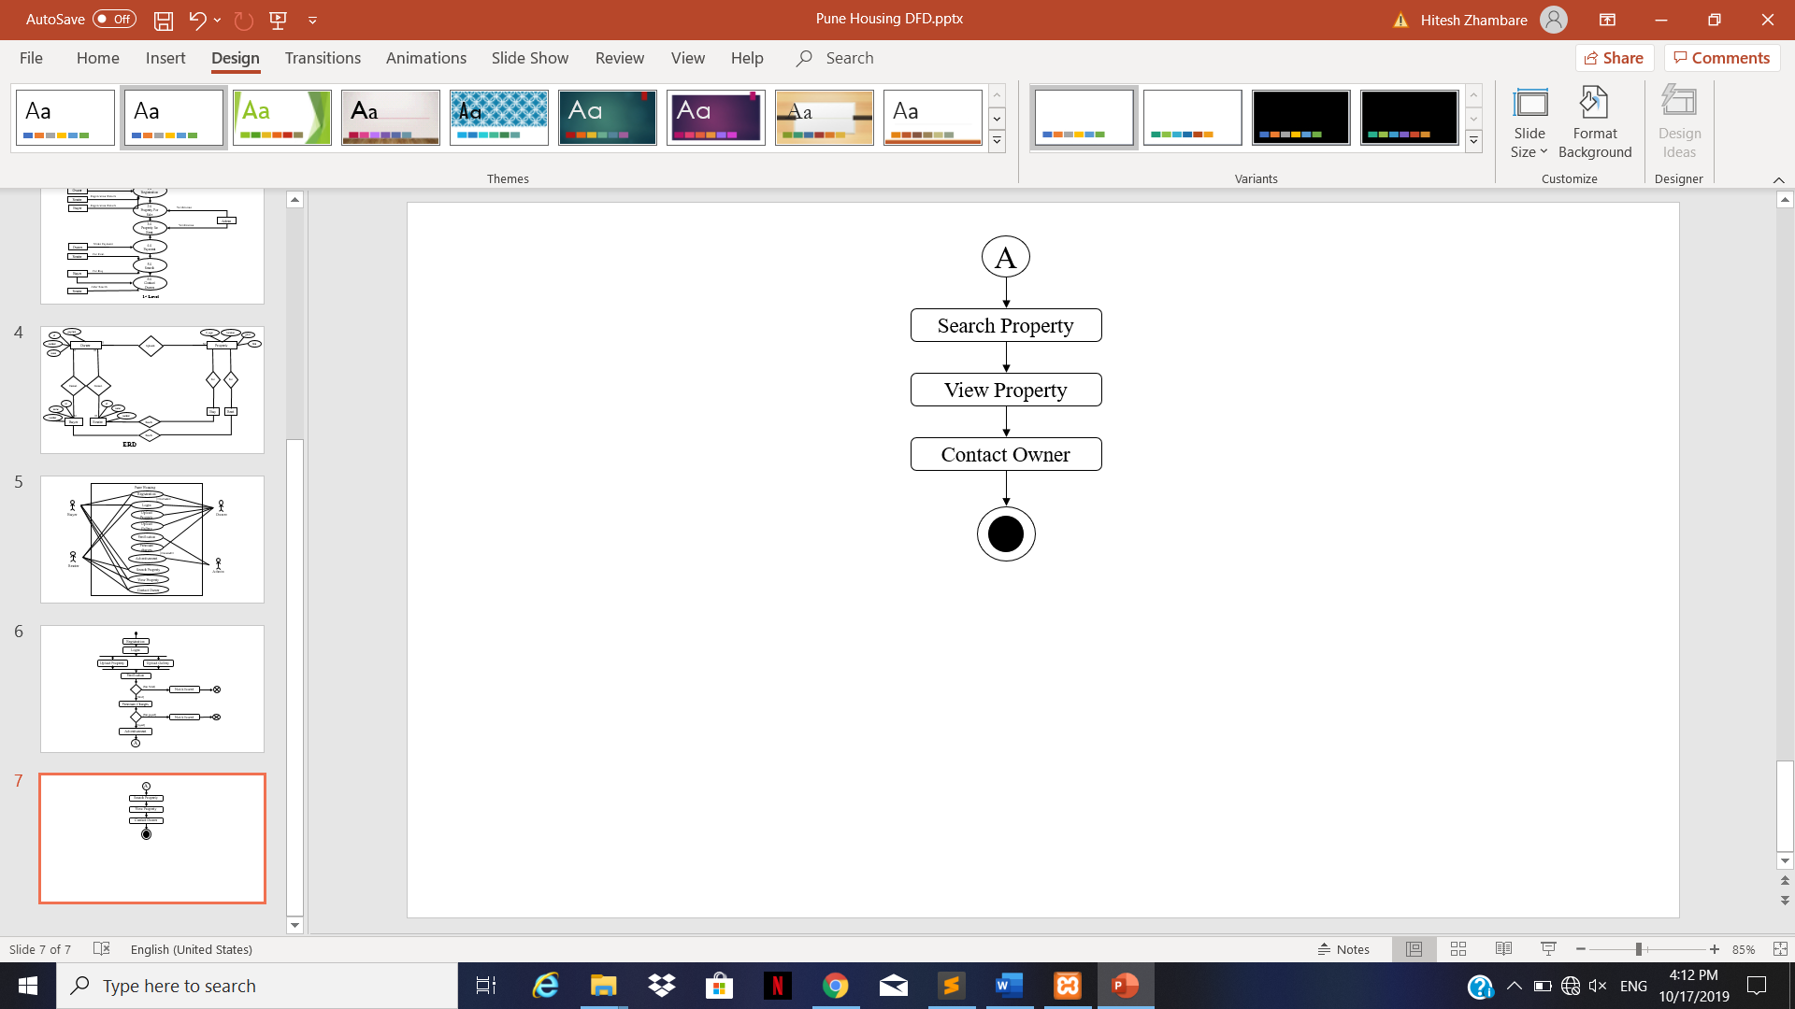

**3.8 Table Design [Sr no. Name, Type, description ] :**

**Table -1 : Housedetails**

|  |  |  |  |  |
| --- | --- | --- | --- | --- |
| **Sr no** | **Name** | **Type** | **Size** | **Description** |
| 1 | Id | Int | 11 | Primary key. |
| 2 | Housetype | Varchar | 30 | Types of houses e.g flat, villa etc. |
| 3 | Area | Int | 10 | Area of propert in suare feet. |
| 4 | Rooms | Int | 3 | 3BHk,4BHK. |
| 5 | Location | Varchar | 30 | Addresses or exact location of property. |
| 6 | Rate | Int | 10 | Average rates and prices. |
| 7 | Building | Varchar | 30 | Name of building. |
| 8 | Ageofproperty | Int | 10 | Age of flat, villa e.g 10 years etc. |
| 9 | Maintenance | Int | 10 | Maintenance. |

**Table-2 : SellerRegistration**

|  |  |  |  |  |
| --- | --- | --- | --- | --- |
| **Sr no** | **Name** | **Type** | **Size** | **Description** |
| 1 | Id | Int | 03 | Primary key. |
| 2 | Name | Text | 30 | Name. |
| 3 | Email | Varchar | 15 | Email address. |
| 4 | Username | Varchar | 15 | Username. |
| E | Password | Varchar | 10 | Password. |
| 6 | Phoneno | Int | 10 | Contact. |
| 7 | Permantadd | Varchar | 50 | Permanent address. |

**Table-3 : BuyerRegistration**

|  |  |  |  |  |
| --- | --- | --- | --- | --- |
| **Sr no** | **Name** | **Type** | **Size** | **Description** |
| 1 | Id | Int | 03 | Primary key. |
| 2 | Name | Text | 30 | Name. |
| 3 | Email | Varchar | 15 | Email address. |
| 4 | Username | Varchar | 15 | Username. |
| E | Password | Varchar | 10 | Password. |
| 6 | Phoneno | Int | 10 | Contact. |
| 7 | Permantadd | Varchar | 50 | Permanent address. |

**Chapter** **4:** **User Manual :**

**4.1 User Manual :**

User should first signup on the website. Also there are some pages which can be accessed before registering also. After registering on the website user can search for types of property that needed. He can click the menu’s to visit particular page. He can view which some details about the company and also check the location of the property and also can check others details.

**Chapter 5 :Drawbacks or Limitation :**

It must be accessed through a web browser.

It is not a mobile app / a website which required browser.

It cannot send push notifications to the user.

The issues are sent to the notification email and communication can only be achieved through messaging/email.

Only restricted to pune city.

**Chapter 6: Future Enhancements :**

Develop mobile application for better user requirement.

Mobile application is a easy way to use for user.

Push notification form server to users.

Adding more cities in future.

**Chapter 7 : Conclusion :**

Effectively resolving the apartment issues is important to the tenant's long-term future, the Rental Property Management website will be an important tool for creating rental housing stability by helping tenants speak with greater credibility through initiating and documenting communications and building productive relationships with landlords. Rent/Buy property management provides tenants of specific housing associations and social landlords with a simple way to report and arrange to rent/buy/sell properties. Finally, the goal of the website is to create a better relationship between tenants and a landlord which can be achieved through this website.

**Chapter 8 : Bibliography :**

[www.housing.com](http://www.housing.com)

[www.w3school.com](http://www.w3school.com)

bootstrap.com

google.com

**Chapter 9:** **Annexures :**

**Annexure: 1 Input Forms With Data (Input screen With Validations)**

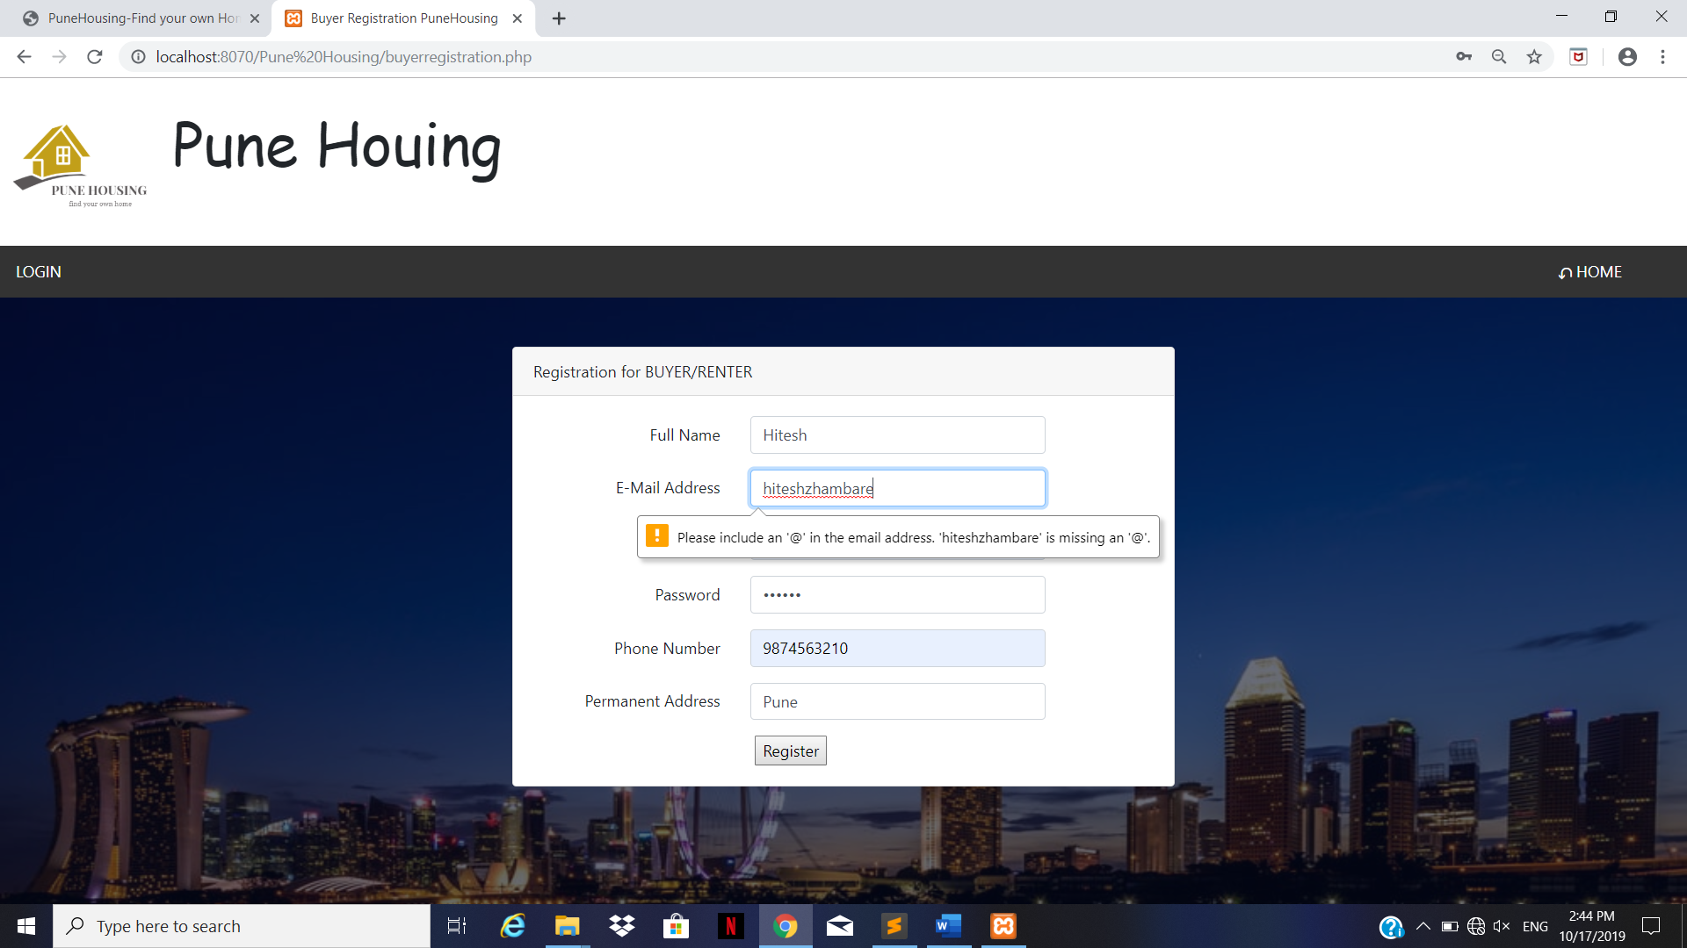

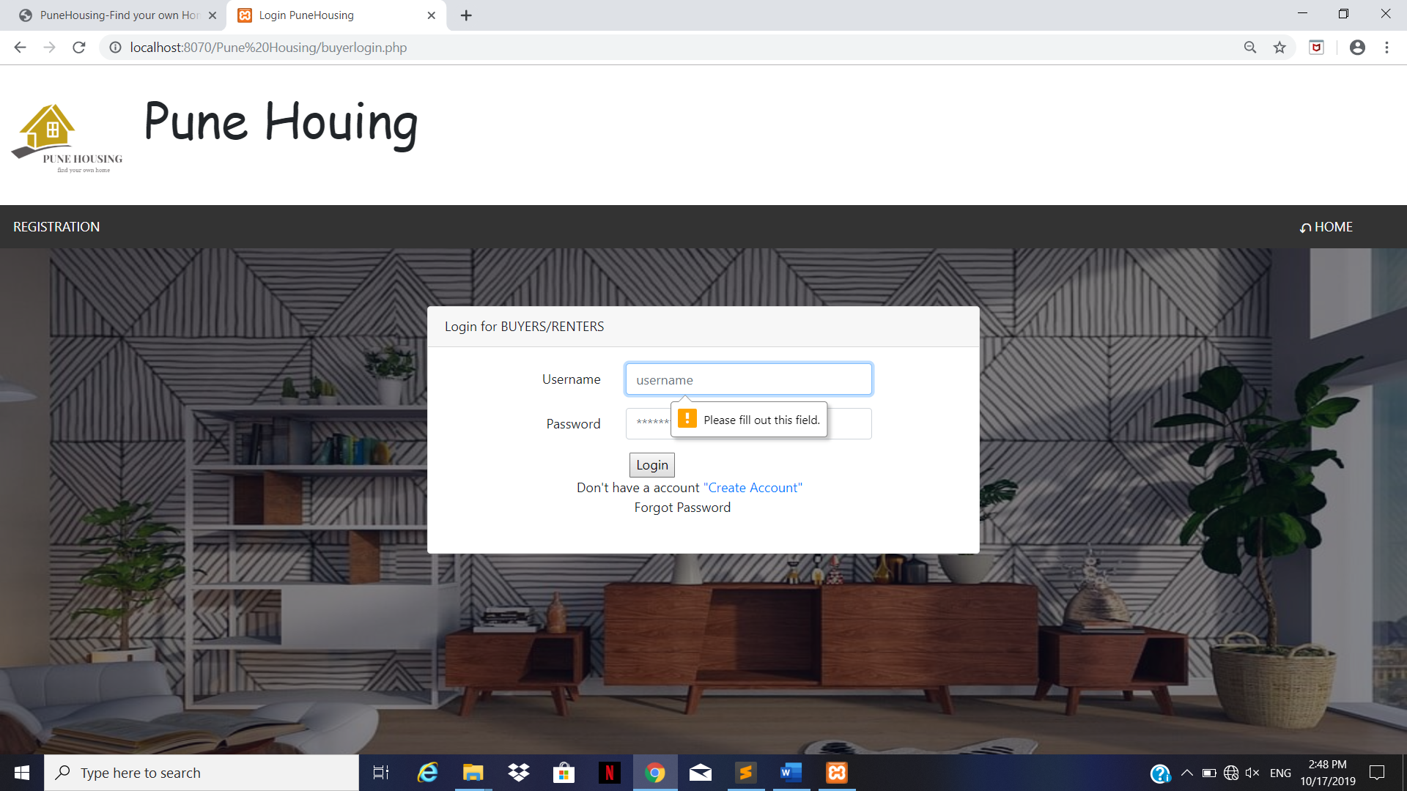

**Annexure: 2 Output Reports With Data :**

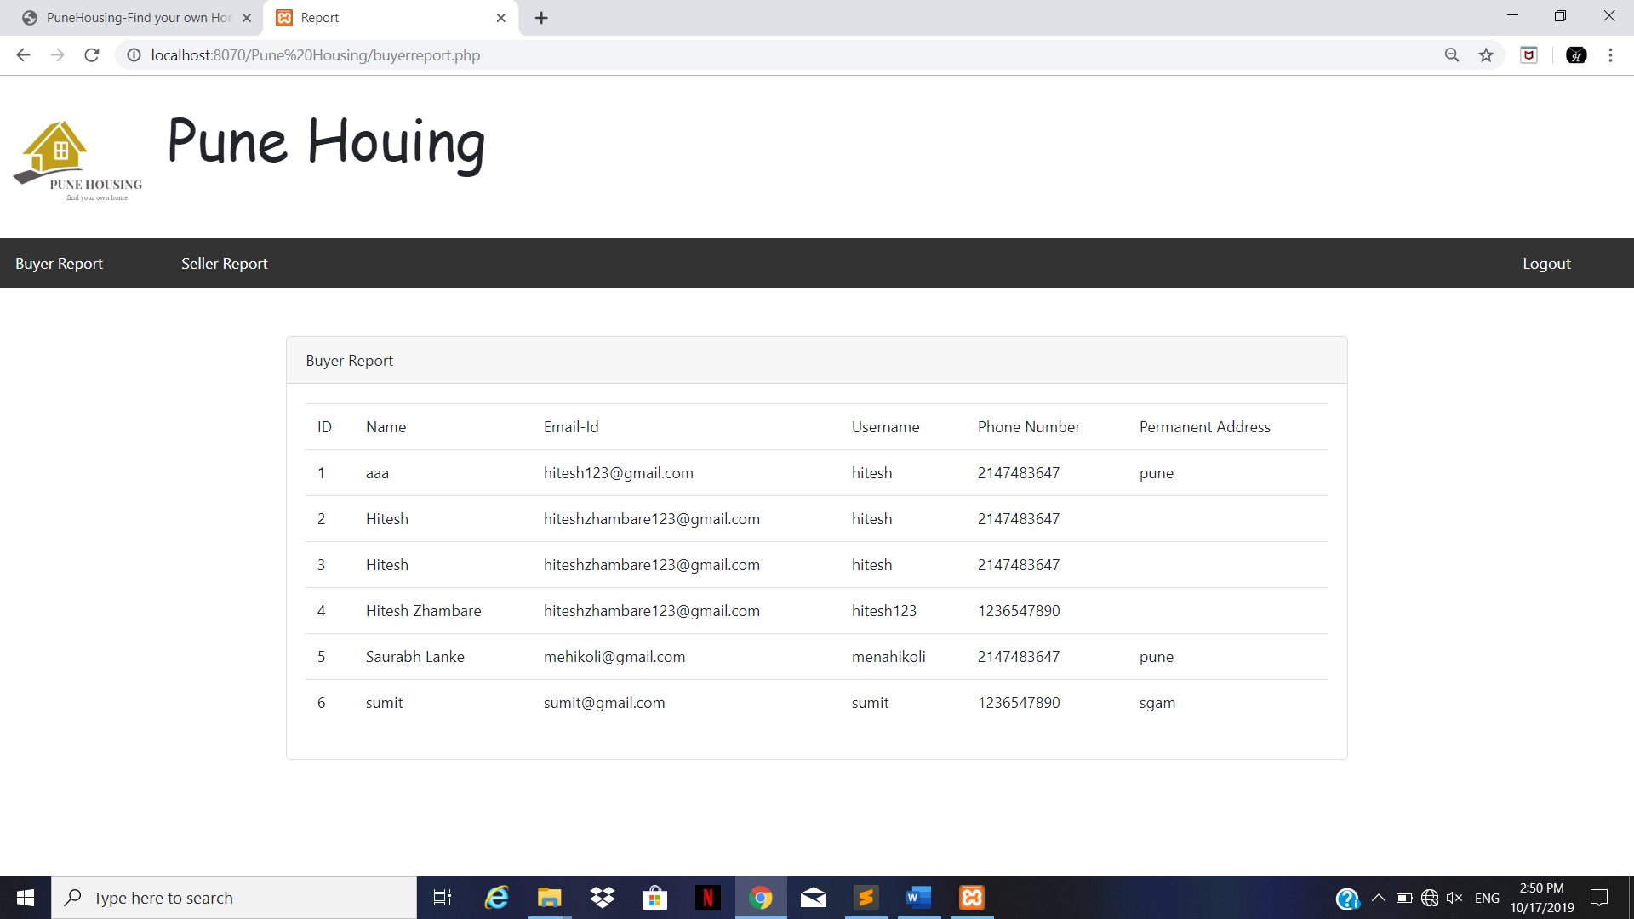

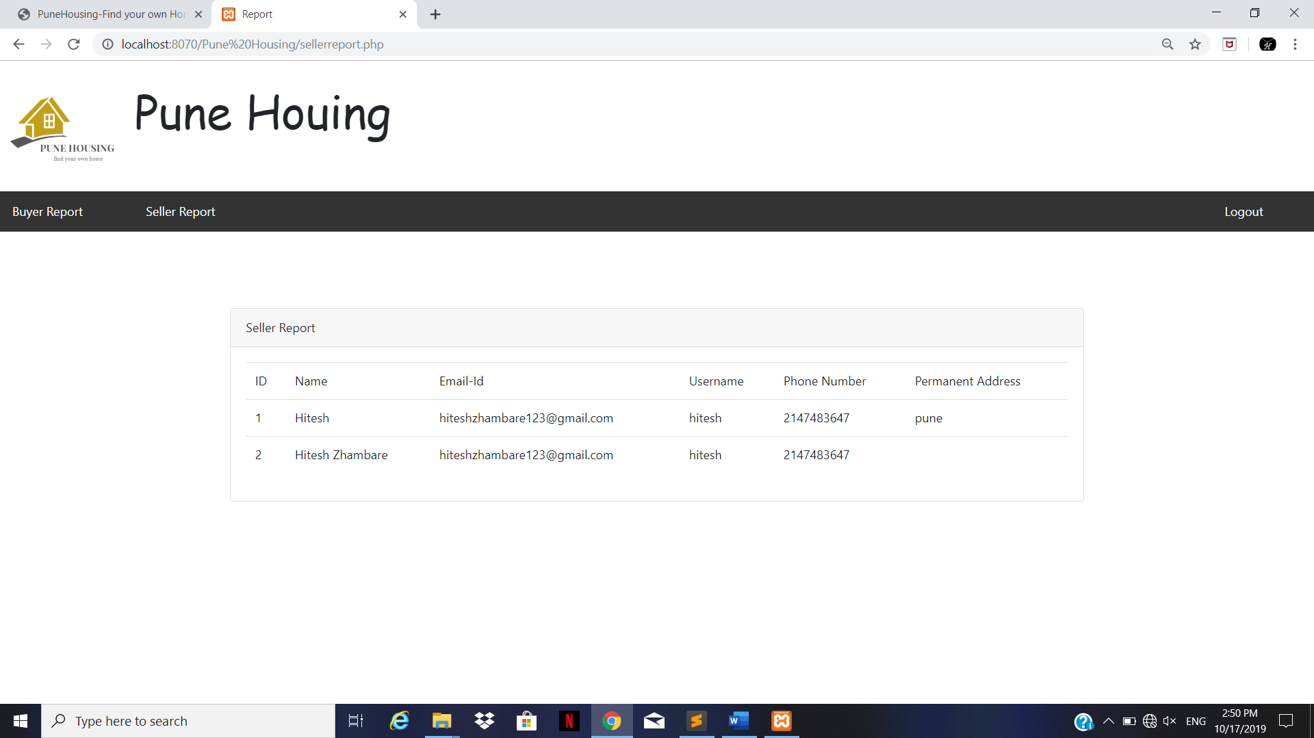

**Annexure: 2 Sample code :**

**HomePage.html**

<html>

<head>

<title>PuneHousing-Find your own Home</title>

<link rel="stylesheet" type="text/css" href="css/homepage.css">

<link rel="stylesheet" href="https://fonts.googleapis.com/icon?family=Material+Icons">

<link rel="stylesheet" href="https://cdnjs.cloudflare.com/ajax/libs/font-awesome/4.7.0/css/font-awesome.min.css">

</head>

<body>

<!-- Main image start -->

<div class="main">

<div style="background-color: rgba(4,9,30,0.5); height:600px;">

<p>

<select class="location" style="color:white; font-size:20px;">

<option style="color:black;">Pune</option>

<option style="text-decoration:italic;color:black;" >More Comeing soon...!</option>

</select>

</p>

<!-- <a href="buyerlogin.html"><p class="login"><i class="material-icons">person</i> Login </p></a> -->

<i class="fa fa-user" style="color:white;font-size:25px;margin-left:1270px;margin-top:-70px;" ></i>

<select class="logins" style="color:white; font-size:20px;" onchange="javascript:handleselect(this)">

<option>Login As</option>

<option value="buyerlogin" style="color:black;">Buyer Login</option>

<option value="sellerlogin" style="color:black;">Seller Login</option>

<option value="adminlogin" style="color:black;">Admin Login</option>

</select>

<script>

function handleselect(elm)

{

window.location=elm.value+".php";

}

</script>

<a href="buyerlogin.php"><p class="buy">Buy</p></a>

<a href="sellerlogin.php"><p class="sell">Sell</p></a>

<a href="buyerlogin.php"><p class="rent">Rent</p></a>

</div>

</div>

<!-- Main image end -->

<!-- diwali offer starts -->

<p style="margin-top:20px;font-size:20px;margin-left:20px;"><b>MEGA HOME UTSAV</b></p>

<div style="margin-top:50px;height:200px;">

<img src="images/megahomwutsav.png">

<div style="margin-top:-225px;margin-left:300px;height:200px;width:200px;">

<br><span style="margin-left:40px;">Mega prize</span><br>

<br><span style="font-size:30px;margin-left:20px;color:pink;">₹ 30 Lakhs</span><br>

<br><span style="margin-left:40px;">Cash Prize</span><br>

</div>

<div style="margin-top:-200px;margin-left:650px;height:200px;width:200px;">

<br><span style="margin-left:40px;">Mega prize</span><br>

<br><span style="font-size:30px;margin-left:20px;color:pink;">₹ 30 Lakhs</span><br>

<br><span style="margin-left:40px;">Cash Prize</span><br>

</div>

<div style="margin-top:-200px;margin-left:1000px;height:200px;width:200px;">

<br><span style="margin-left:40px;">Mega prize</span><br>

<br><span style="font-size:30px;margin-left:20px;color:pink;">₹ 30 Lakhs</span><br>

<br><span style="margin-left:40px;">Cash Prize</span><br>

</div>

<button class="explorebtn"style="">Explore Now &rarr;</button>

</div>

<!-- Trending Projects starts -->

<div style="height:300px; margin-top:50px;">

<div style="width:100%;">

<h2 style="margin-top:20px;margin-left:20px;">Trending Projects</h2>

<div class="trendpro">

<div><img src="images/trending1.jpg" style="margin-left:20px;margin-top:20px;" height="180px" width="180px"></div>

<div style="margin-left:220px;margin-top:-180px;;height:180px;width:180px;">

<br><br><label style="font-size:20px;"><b>Pebbles Urania</b></label><br><br>

<label style="font-weight:100;">Hinjewadi</label><br><br>

<label><b>₹1 Cr - ₹1.5 Cr</b></label>

</div>

</div>

<div class="trendpro">

<div><img src="images/trending2.jpeg" style="margin-left:20px;margin-top:20px;" height="180px" width="180px"></div>

<div style="margin-left:220px;margin-top:-180px;;height:180px;width:180px;">

<br><br><label style="font-size:20px;"><b>Belvakar Sarita</b></label><br><br>

<label style="font-weight:100;">Wakad</label><br><br>

<label><b>₹90 L - ₹1.2 Cr</b></label>

</div>

</div>

<div class="trendpro">

<div><img src="images/trending3.jpeg" style="margin-left:20px;margin-top:20px;" height="180px" width="180px"></div>

<div style="margin-left:220px;margin-top:-180px;;height:180px;width:180px;">

<br><br><label style="font-size:20px;"><b>Siddhashila Eela</b></label><br><br>

<label style="font-weight:100;">Hadapsar</label><br><br>

<label><b>₹75 Lakh - ₹90 Lakh</b></label>

</div>

</div>

</div>

</div>

<!-- Trending Project Ends -->

<!-- Featured Collection start -->

<div style="margin-top:50px;height:500px;">

<div>

<div class="indehouse">

<h2 style="margin-top:175px;margin-left:160px;;color:white;">Independent House</h2>

</div>

<div class="rtmi"><br><br><br><br><br><br><br><br>

<h2 style="margin-left:160px;;color:white;">Ready To Move In</h2>

</div>

</div>

<div style="margin-top:20px;">

<div class="town">

<h2 style="margin-top:175px;;margin-left:210px;;color:white;">Township</h2>

</div>

<div class="luxry"><br><br><br><br><br><br><br><br>

<h2 style="margin-left:230px;;color:white;">Luxry</h2>

</div>

</div>

</div>

<!-- Featured Collection end -->

<!-- Footer starts -->

<div class="footer">

<div class="contactus">

<center><h1 style="font-size:35px;">Contact US</h1></center>

<p style="margin-left:10px;"><img src="images/flag.png" height="13px" width="20px"> (+91)738-908-4614<br>

<img src="images/gmail.png" style="border-radius: 2px; height: 13px; width: 20px;">

E-mail :- hiteshzhambare123@gmail.com<br>

Address :<br>

Dr. D Y Patil Campus<br>

Akurdi-(Pune) 411-044<br>

Maharastra</p>

</div>

<div class="aboutus">

<center><h1 style="font-size:35px;">About US</h1></center>

<p align="center"></p>

</div>

<div class="socialsites">

<div>

<i class="fa fa-twitter" style="font-size:50px;color:#1ad1ff;cursor: pointer;"></i>&nbsp;&nbsp;

<i class="fa fa-facebook-square" style="font-size:50px;color:#0000ff;cursor: pointer;"></i>&nbsp;&nbsp;

<i class="fa fa-instagram" style="font-size:48px;color:white;cursor: pointer;"></i>&nbsp;&nbsp;

<i class="fa fa-youtube-play" style="font-size:48px;color:red;cursor: pointer;"></i>

</div>

<div style="margin-top: 10px;">

<label>We'll send you a updates related to your interest</label><br><br>

<input type="email" name="uemail" placeholder="Enter Email" style="height:25px;width:250px;"><br><br>

<input type="button" name="Submit" value="Submit">

</div>

</div>

</div>

<!-- Footer Ends -->

</body>

</html>